Launch one EC2 using Amazon Linux 2 image and add a script in user data to install Apache.
Step 1
Go to
AWS Console → EC2 → Launch Instance

Configuration
- Name: AmazonLinux-Apache
- AMI: Amazon Linux 2023
- Instance Type: t3.micro
- Key Pair: Select existing or create one
- Security Group:
  - SSH (22)
  - HTTP (80)
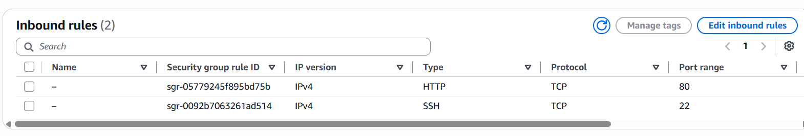

User Data: Under Advanced Details → User Data
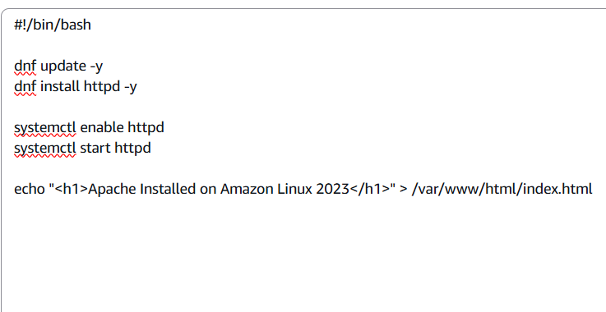
Launch the instance. And browse with public ip address.
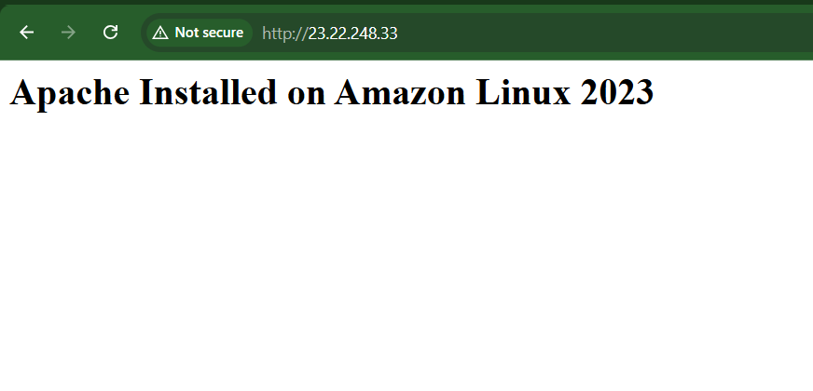

Launch one EC2 using Ubuntu image and add a script in user data to install Nginx.
Configuration
- Ubuntu Server 26.04 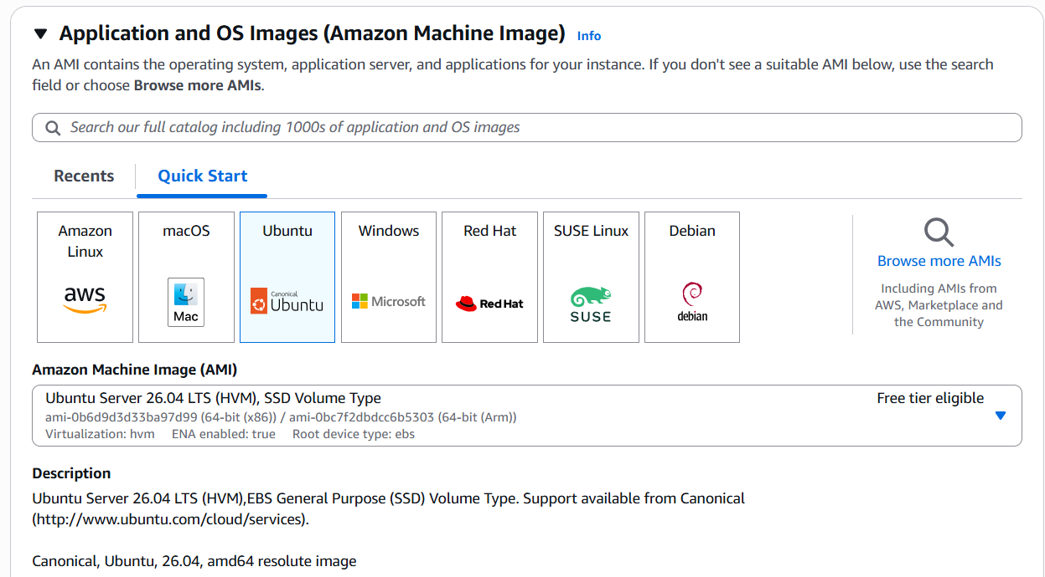
- T3.micro
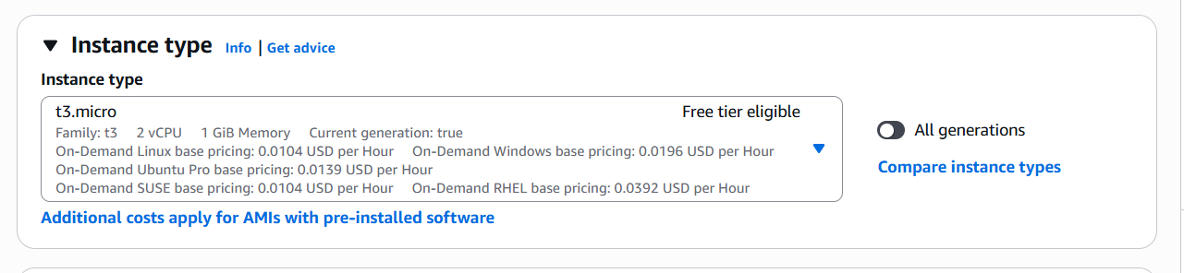
- Allow
  - SSH (22)
  - HTTP (80)
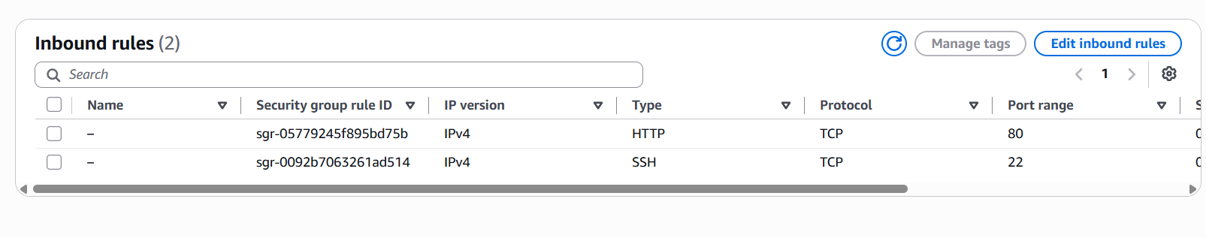

User Data
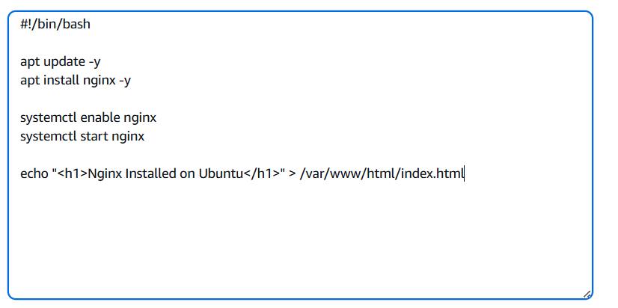
Launch the instance. And browse with public ip address
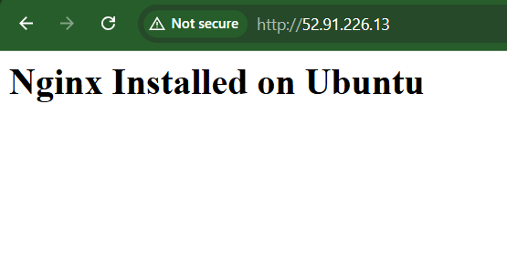
- Launch one Windows server and install Tomcat on Windows.

Step 1: Launch a Windows EC2 Instance
- Go to AWS Console → EC2 → Instances.
- Click Launch Instance.
- Configure:
  - Name: Windows-Tomcat
  - AMI: Windows Server 2025 Base
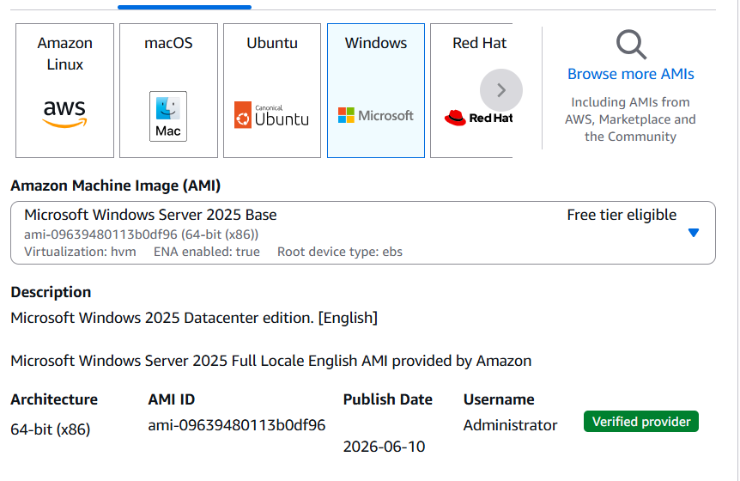
  - Instance Type: t3.micro
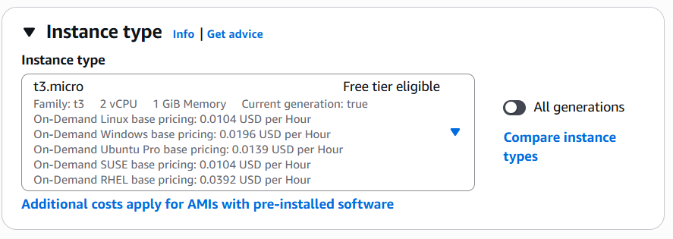
  - Key Pair: Select an existing key pair or create a new one.
  - Security Group: Allow:
    - RDP (3389) from your IP 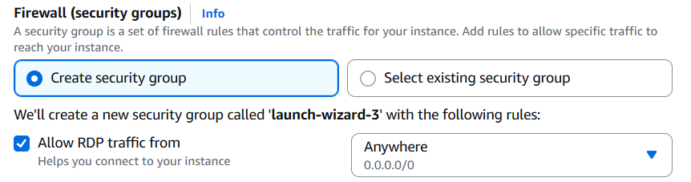
    - Custom TCP (8080) from Anywhere (0.0.0.0/0) so you can access Tomcat.
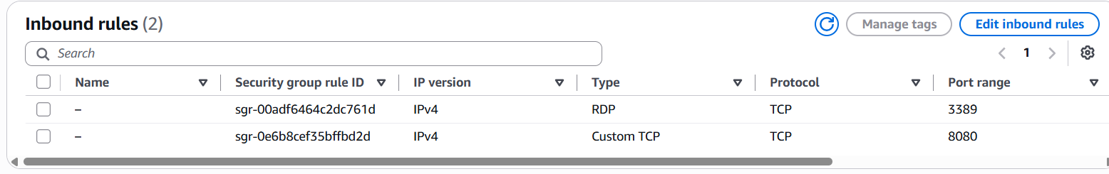
- Click Launch Instance.

Step 2: Connect to the Windows Server
Wait until the instance status is Running.
- Select the instance.
- Click Connect.
- Choose the RDP Client tab.
- Click Get Password.
- Upload your .pem key pair file.
- Click Decrypt Password.
- Copy:
  - Username: Administrator
  - Password
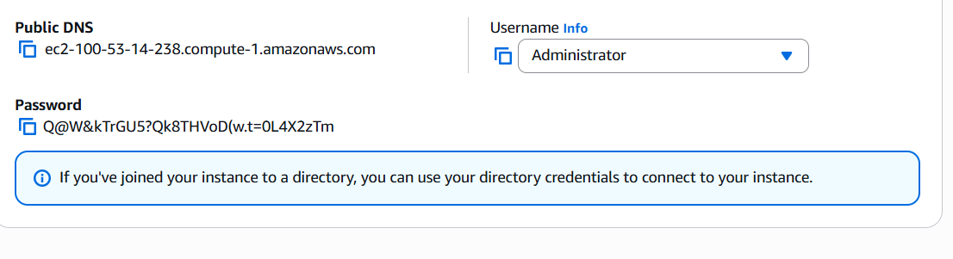

Connect using mobaxterm as it is easy for us to manage with two windows using RDP session
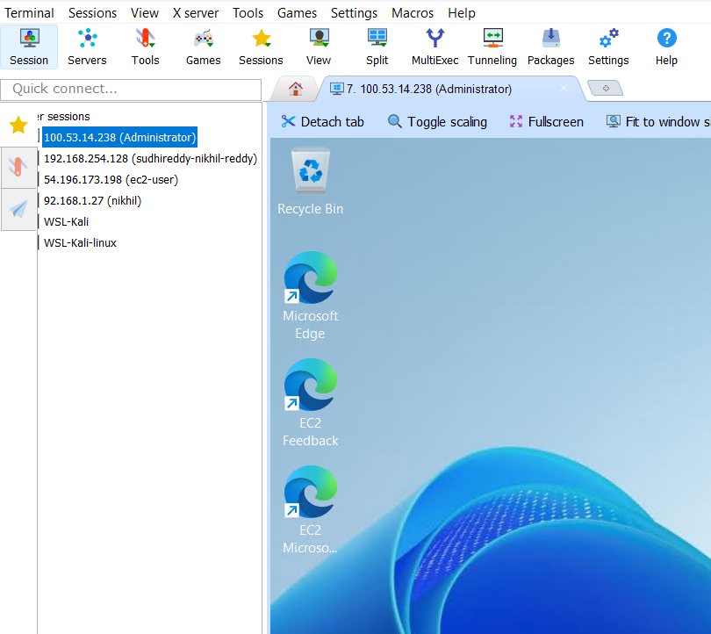
Step 3: Download and Install Java JDK
Apache Tomcat requires Java to run.
- Open Microsoft Edge.
- Visit the Eclipse Adoptium website.
- Download:
OpenJDK 21 (Windows x64 MSI)

Step 4: Verify Java Installation
Open Command Prompt and execute:
java -version
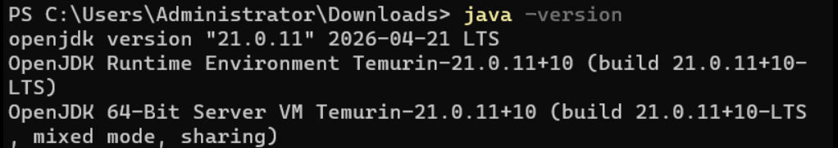

Step 5: Download Apache Tomcat
- Open Microsoft Edge.
- Visit the Apache Tomcat website.
- Download:
Apache Tomcat 10.1.57 64-bit Windows ZIP
Extract the ZIP file to:
C:\Tomcat
Resulting folder:
C:\Tomcat\apache-tomcat-10.1.57

Step 6: Configure JAVA_HOME
Navigate to:
Control Panel
→ System
→ Advanced System Settings
→ Environment Variables
Create a new System Variable.
Variable Name
JAVA_HOME
Variable Value
C:\Program Files\Eclipse Adoptium\jdk-21.0.11.10-hotspot
Edit the Path system variable and add:
%JAVA_HOME%\bin
Click OK and restart the Command Prompt.

Step 7: Start Apache Tomcat
Open Command Prompt.
Navigate to the Tomcat bin directory.
cd C:\Tomcat\apache-tomcat-10.1.57\bin
Start Tomcat.
startup.bat

Step 8: Verify Tomcat
Open Microsoft Edge inside the Windows Server.
Browse to:
http://localhost:8080
The Apache Tomcat Welcome Page should be displayed successfully.

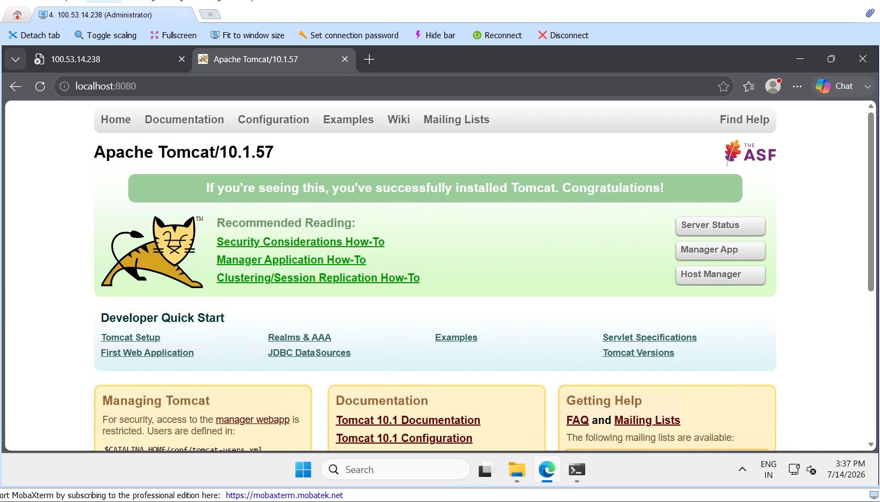

Take a snapshot of the instance created in Task 1.
Objective
Create an Amazon EBS snapshot of the Amazon Linux EC2 instance created in Task 1.

Procedure

Step 1: Open EC2 Console
- Log in to the AWS Management Console.
- Navigate to EC2 Dashboard.
- Click Instances.

Step 2: Select the Amazon Linux Instance
- Select the Amazon Linux instance created in Task 1.
- Click the Storage tab.
- Under Block Devices, click the Volume ID.
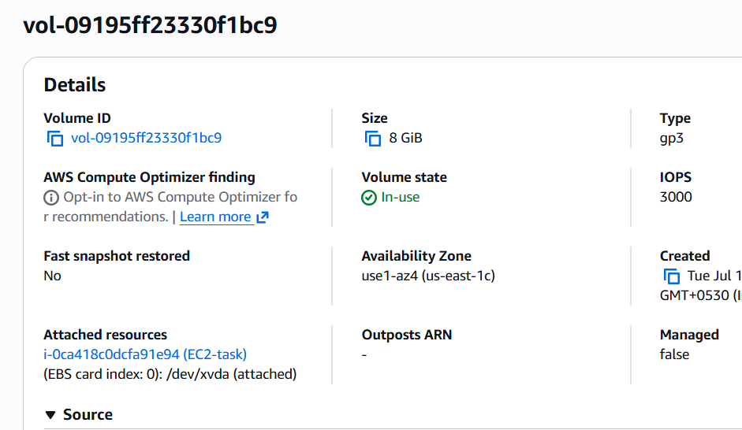

Step 3: Create Snapshot
- Select the volume.
- Click Actions → Create Snapshot.
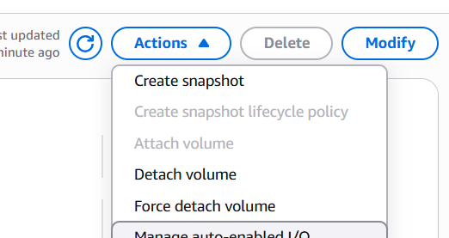
- Enter:
Description
Amazon Linux Root Volume Snapshot
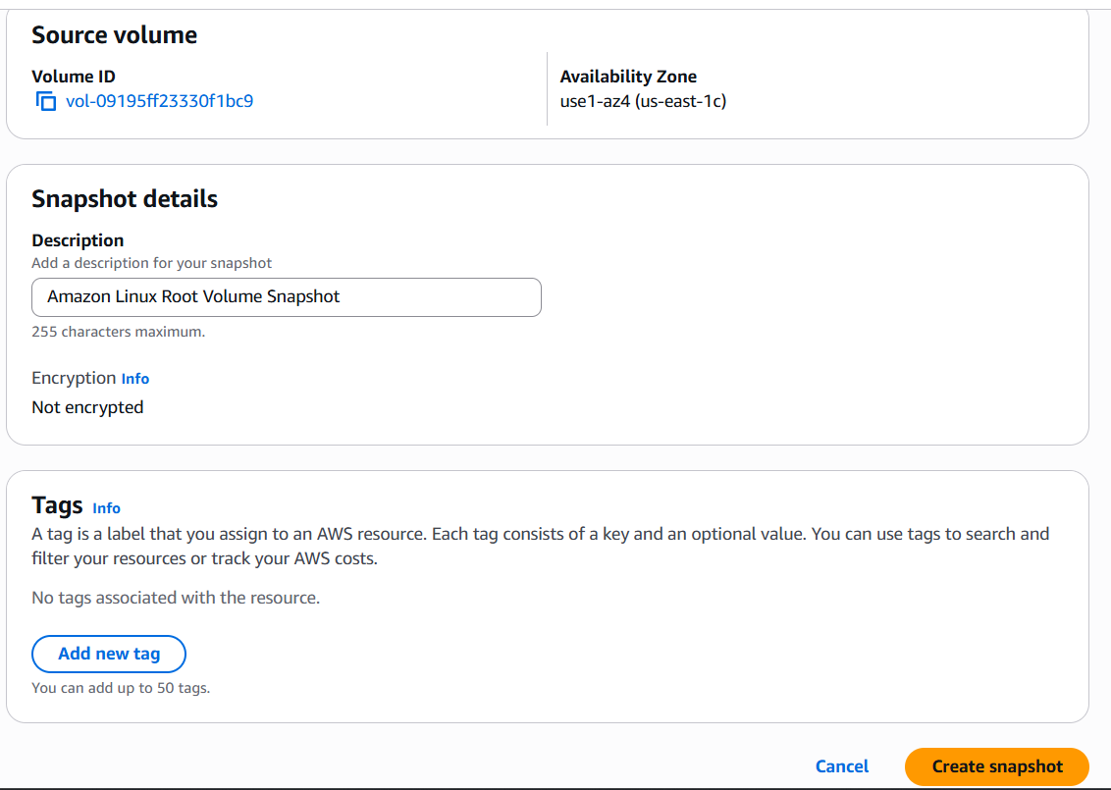
- Click Create Snapshot.

Step 4: Verify
Go to:
EC2 → Elastic Block Store → Snapshots
Wait until the snapshot status changes to:
Completed

Result
Successfully created an EBS snapshot of the Amazon Linux EC2 instance.
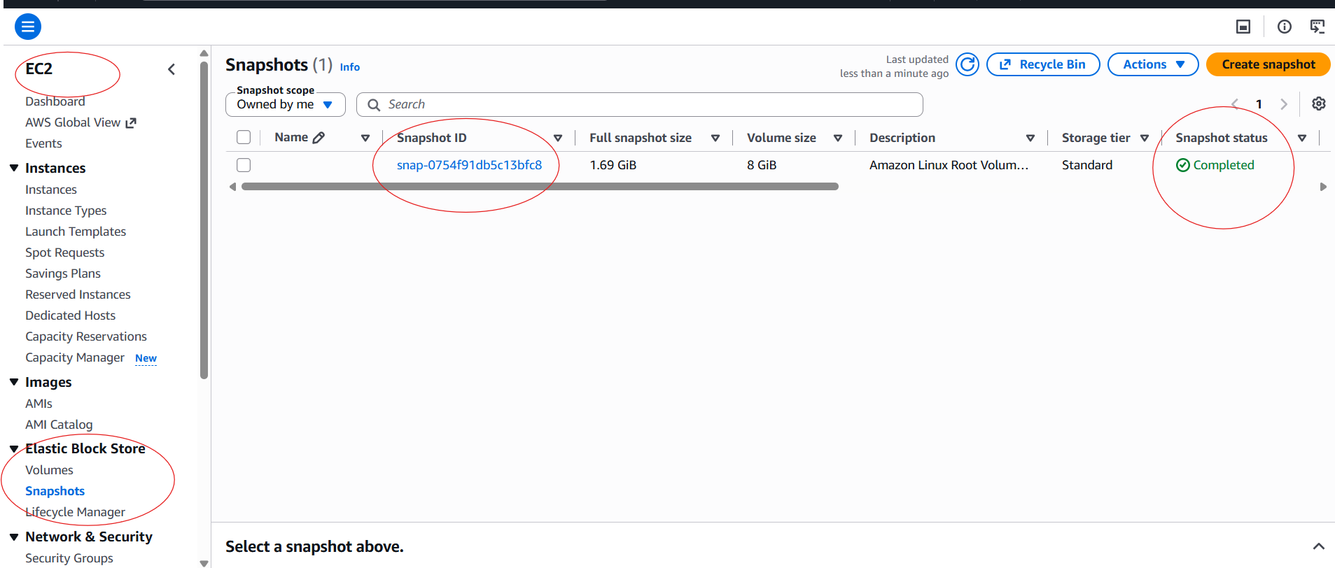

Assign passwordless authentication for the EC2 created in Task 2.
Objective
Configure SSH key-based authentication.

Prerequisites

Step 1: Generate SSH Key Pair
ssh-keygen
Press Enter for all prompts.
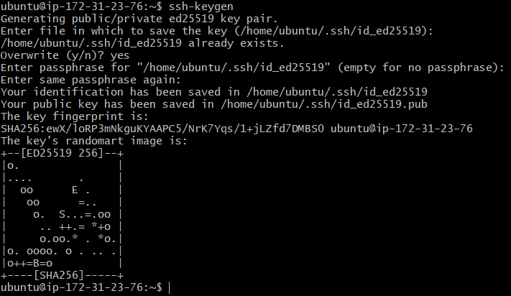

Step 2: Display Public Key
cat /home/ubuntu/.ssh/id_ed25519.pub
Copy the output.
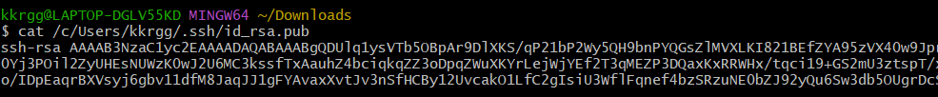

Step 3: Connect to EC2 Instance
ssh -i challenge.pem ubuntu@<Public-IP>
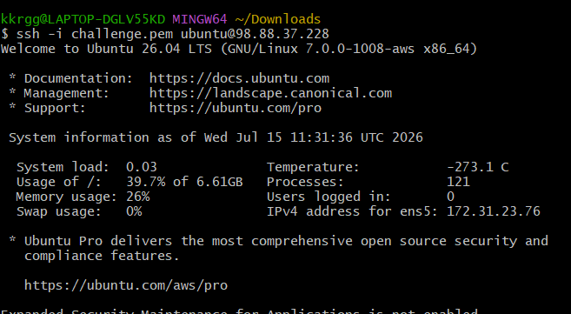

Step 4: Configure Authorized Keys
nano ~/.ssh/authorized_keys
Paste the copied public key.
Save the file.
Set permissions:
chmod 700 ~/.ssh
chmod 600 ~/.ssh/authorized_keys

Step 5: Test Passwordless Login
ssh ubuntu@<Private-IP>
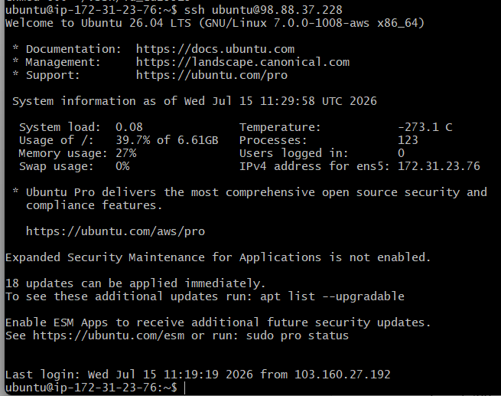
The connection should be established without using the .pem file.

Result
Passwordless SSH authentication configured successfully.

Launch any EC2 using the spot purchasing option.
Objective
Launch an EC2 instance using the Spot purchasing model.

Procedure
- Open EC2 Dashboard.
- Click Launch Instance.
- Enter the instance name:
Spot-Instance
- Select an Amazon Machine Image (AMI), for example:
Amazon Linux 2023
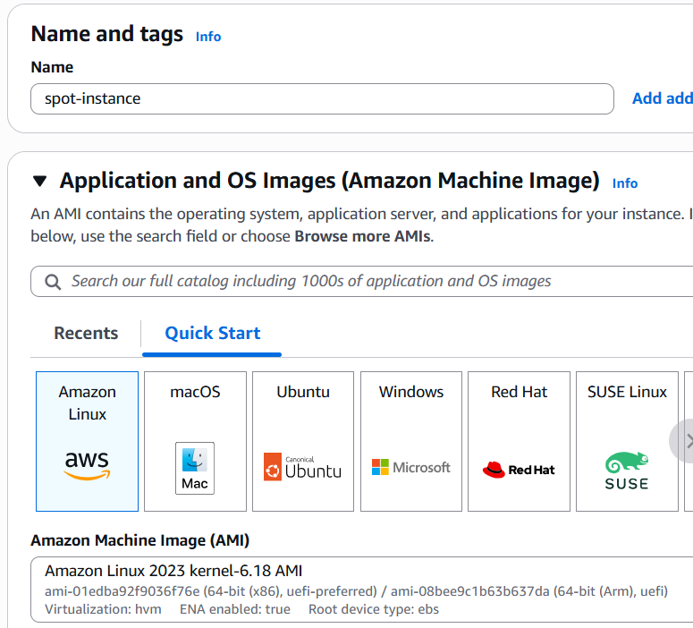
- Select the instance type:
t2.micro
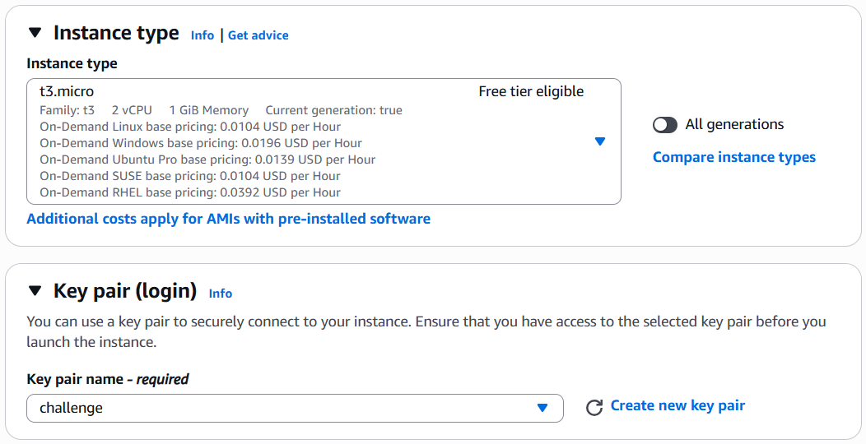
- Expand Advanced Details.
- Locate Request Spot Instances.
- Enable:
Request Spot Instances
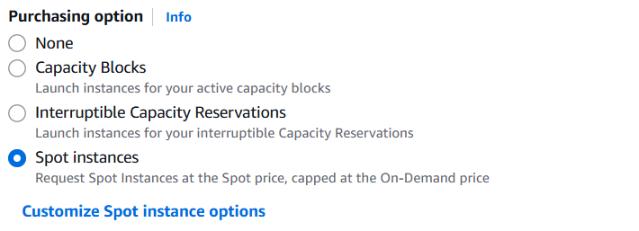
- Leave the default Spot request settings (or set a maximum price if required).
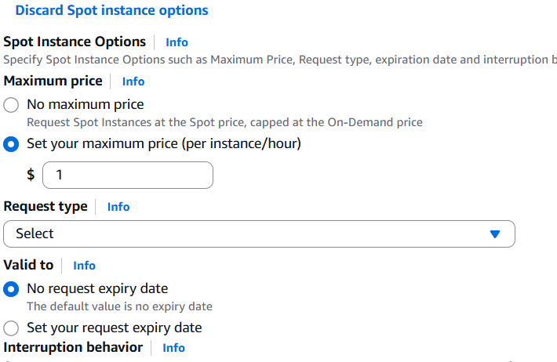
- Choose a key pair.
- Configure the security group.
- Click Launch Instance.
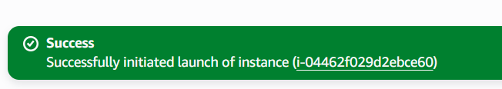

Verify
The Lifecycle column should display:
Spot
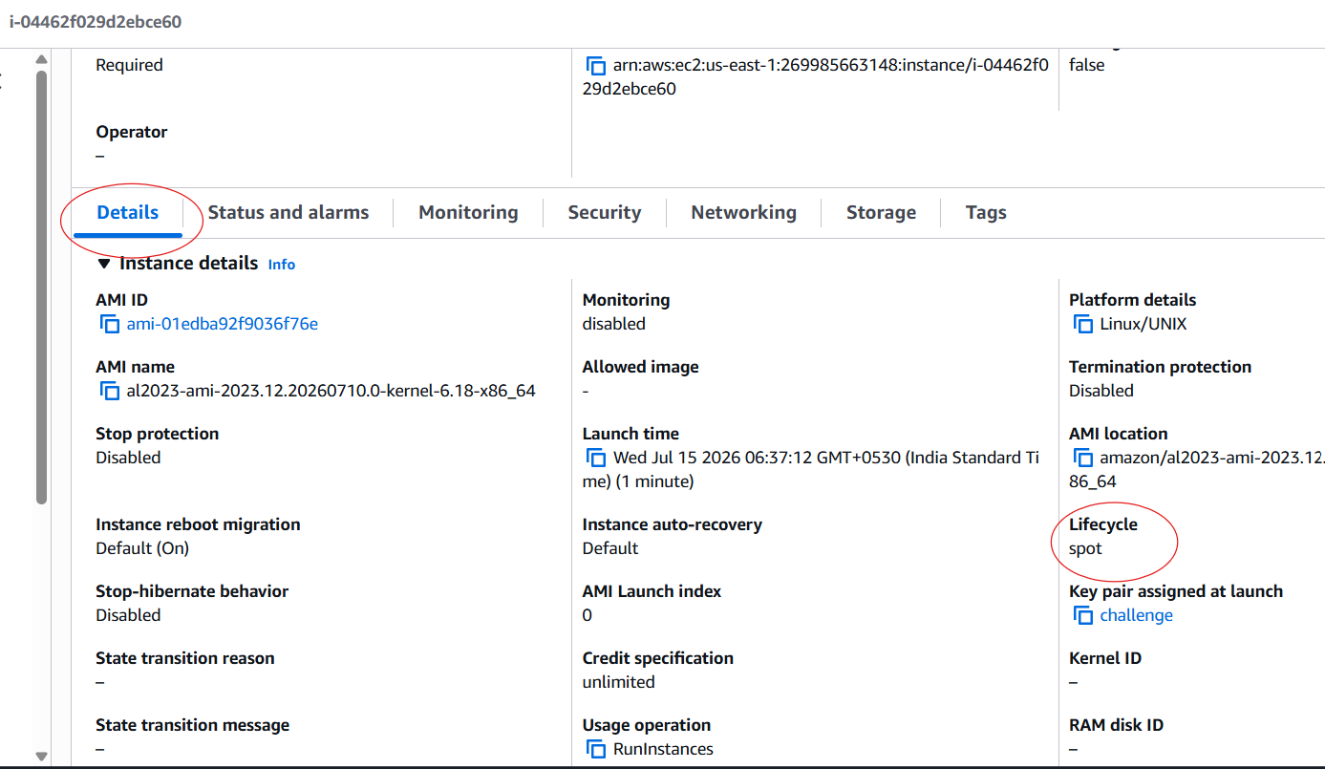

Result
Successfully launched an EC2 Spot Instance.

Enable termination policy on the EC2 created in Task 2.
Objective
Enable termination protection to prevent accidental deletion.

Procedure
- Open EC2 Dashboard.
- Select the Ubuntu EC2 instance.
- Click:
Actions
→ Instance Settings
→ Change Termination Protection
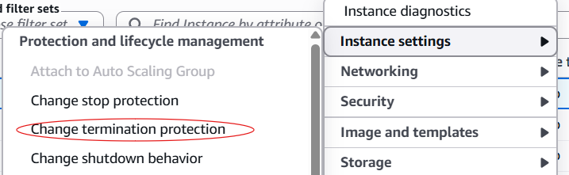
- Select:
Enable
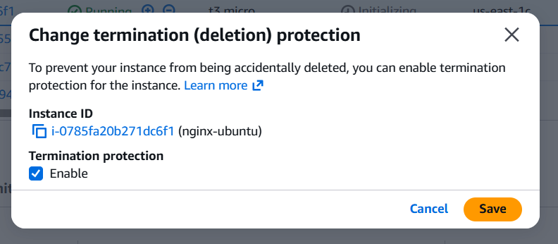
- Click Save.

Verification
Attempting to terminate the instance will display an error indicating that termination protection is enabled.
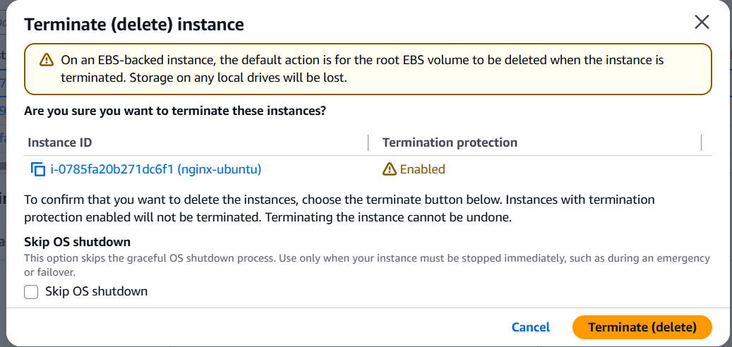

Result
Termination protection enabled successfully.
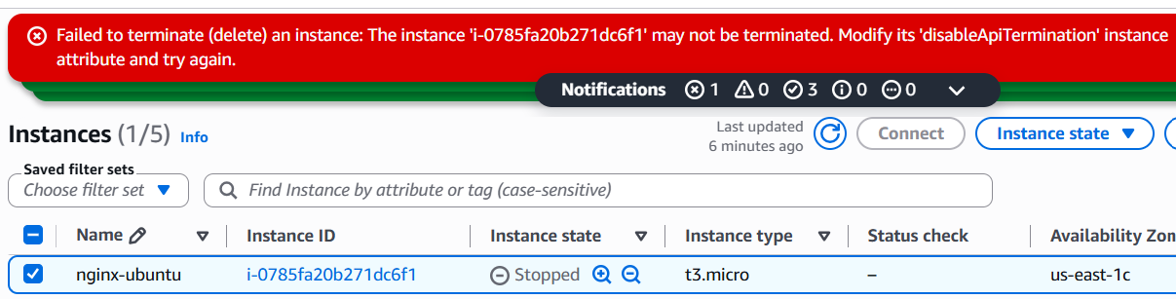

Launch one EC2 using AWS CLI.
Prerequisites

AWS CLI installed
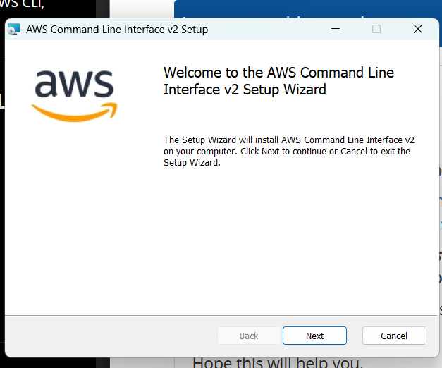
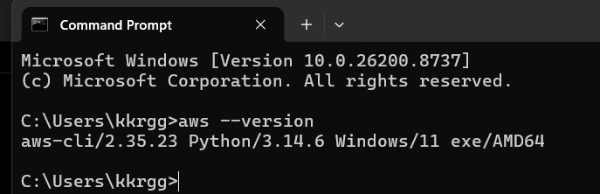
Create an IAM User
- Sign in to the AWS Console as the root user.
- Go to IAM → Users → Create user.
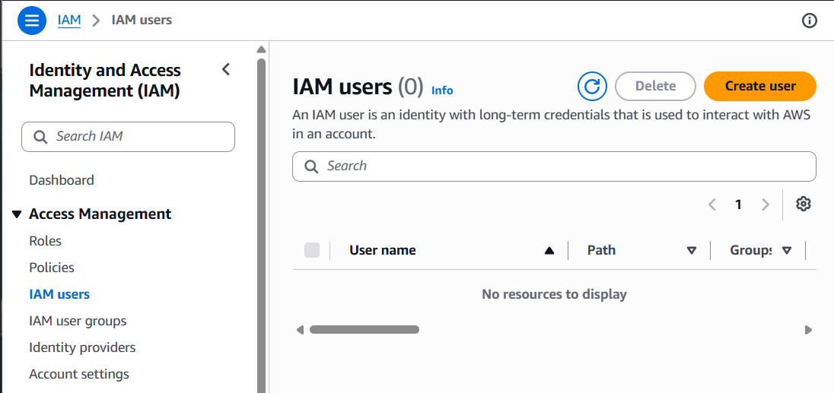
- Enter a username (for example, cli-user).
- Attach the AdministratorAccess policy.
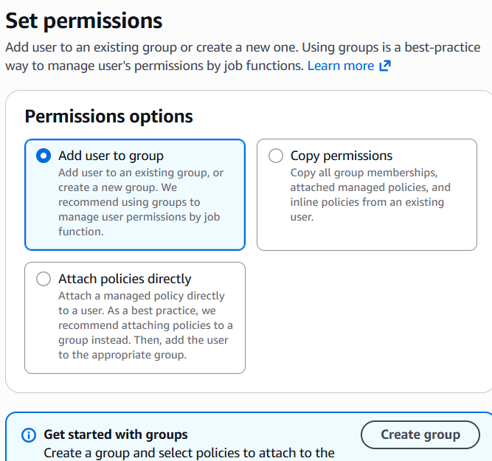
- Create the user.
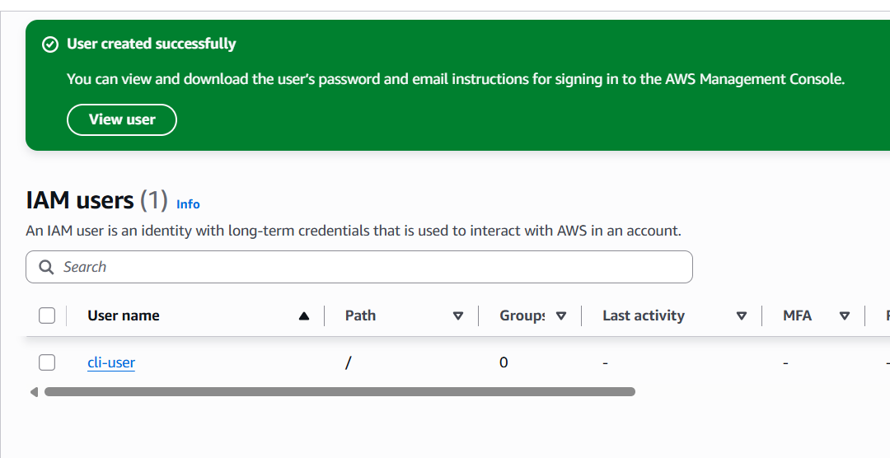
- Open the new user → Security credentials → Create access key → choose Command Line Interface (CLI).
- Copy the Access Key ID and Secret Access Key

- AWS CLI configured using:
aws configure
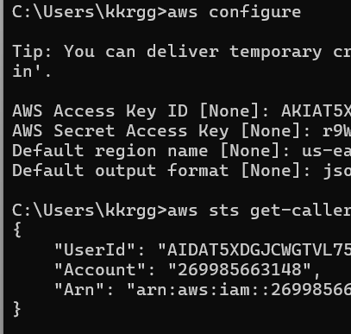
Provide:
- AWS Access Key ID
- AWS Secret Access Key
- Region
- Output format

Launch EC2 Instance
Example command:
aws ec2 run-instances \
--image-id ami-xxxxxxxxxxxxxxxxx \
--instance-type t2.micro \
--key-name MyKeyPair \
--security-group-ids sg-xxxxxxxxxxxxxxxxx \
--subnet-id subnet-xxxxxxxxxxxxxxxxx \
--count 1
Replace:
- ami-xxxxxxxxxxxxxxxxx with your AMI ID
- MyKeyPair with your key pair name
- sg-xxxxxxxxxxxxxxxxx with your security group ID
- subnet-xxxxxxxxxxxxxxxxx with your subnet ID
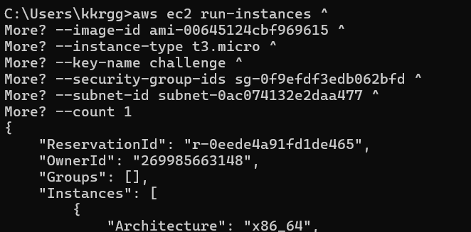

Verify Instance
check the EC2 Console → Instances page.
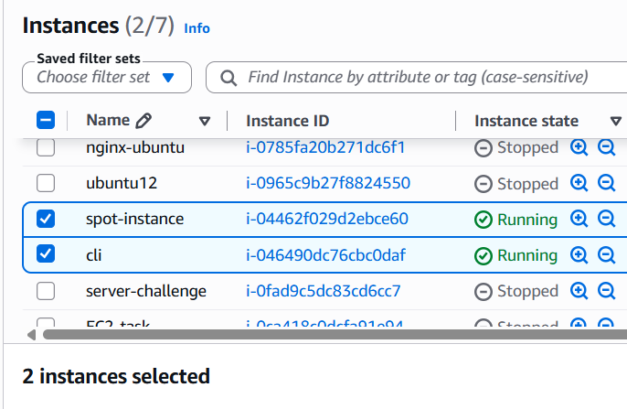

Result
Successfully launched an EC2 instance using the AWS CLI.

